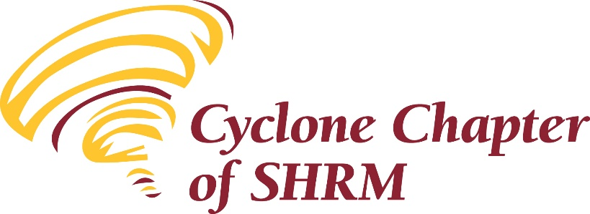 | 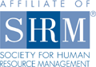

Meeting Minutes
September 13, 2018

The meeting was called to order by Brenda Dreyer, chapter vice president, at 8:10 a.m.

Present: 48 Human Resource Professionals

Annual Membership Appreciation event

Financials:
The August 31, 2018, financial report was attached to the meeting announcement. Balances were:
- Checking - $22,326.39
- Savings - $1,781.81
- CD #1 - $10,960.23
- CD #2 - $5,319.44
Motion was made and seconded to approve the August 2018, financials as presented. Motion carried.

Minutes:
The minutes of the August 9, 2018 meeting were posted on the chapter website and attached to the meeting announcement. Motion was made and seconded to approve the minutes as presented. Motion carried.

New Business:
Brenda shared the following items:
- Vicki Hales, Business Teacher at Ames High School send her thanks to everyone who was able to complete the resume survey. In addition, if there are any members who are interested in presenting/leading a session to the students directly on resumes, cover letters, interviews, etc., please reach out to Kaela Black to make the connection.
- HR Magazine, published by SHRM, is looking to talk with HR professionals in our area about how they are affected by the low unemployment rate and whether they are finding creative ways to locate and train new workers. If you are interested in talking with HR Magazine about this topic, please reach out to Kaela Black to make the connection.
Old Business:
- The Iowa SHRM State Conference will be held September 26-28, in Coralville.
- Ames High School will be conducting a career fair on October 10. The business teachers are encouraging businesses and individuals to consider participating.
- Ballots for the 2019 Executive Committee will be posted in the next couple of weeks. An email will be sent out with a link to the voting. If you are interested in an executive committee position, please contact Kaela Black no later than Monday, September 17. We encourage you to volunteer and further assist our professional association.
- The executive committee is seeking volunteers to work on a sub-committee to plan and organize the 2019 programming calendar monthly meetings. Please contact Kaela Black as soon as possible if you are interested in participating.

Sharing of Accomplishments, Celebrations and Job Opportunities:
- The next Manpower Excellence in the Workplace seminar, Succession Planning for Yourself will be held October 9 at DMACC in Ankeny.
- Deb Malsom shared that Manpower is staffing an HR Manager position
- Jill Pretzer shared that ISU is seeking a HR Communications Specialist

Business meeting adjourned.

Program Presenter: Dr. Celina Peerman
- Topic: Leading Forward

Closing
Meeting adjourned at 10:00 a.m. The next meeting will be on Thursday October 11, 2018, at the First National Bank.

Respectfully submitted,
Kevin Stow
Secretary

