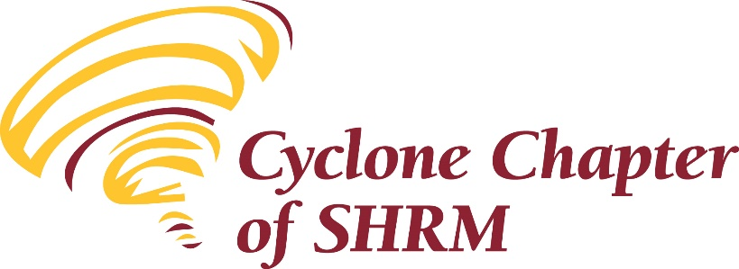

Meeting Minutes
August 13, 2020

Heather Cook, President kicked off the morning’s meeting at 8:02 am. Members checked in via Zoom chat function; as meeting progressed we had 37 people check in, including some new members and a student chapter member.

Heather facilitated a group icebreaker focused on discussing 2020 trend predictions. What has come true?

The July 2020, financial reports were attached to the meeting reminder. The 7/31/20 balances were:
- Checking – $19,037.89
- Savings – $1,783.56
- CD #1 – $11,124.58
- CD #2 – $5427.51
Motion by Lauren Cook to accept the July 2020 financial reports; second by Tammy Stegman. Members affirmed the motion via Zoom. Motion carried.

Minutes:
The minutes of the June and July 2020 meetings were attached to the August meeting announcements. Motion by Kevin Stow to approve the minutes as presented; second by Michelle Price. Members affirmed the motion via Zoom. Motion carried.

Committee Reports:
Vice President-Membership / Lauren Cook
We are in the midst of a membership drive. We sent a mailing out to national members across the State of Iowa; we have had two people join our organization as a result of the mailing.

Lauren reminded membership that we are looking ahead to 2021. She identified Board positions needing to be filled.

Treasurer / Kevin Stow
Kevin described the treasurer responsibilities.

College Relations / Tammy Stegman
Tammy explained her role.

Tammy reminded group that we support the ISU student chapter by paying their national SHRM dues.

Tammy highlighted a new mentoring program we will be launching with the ISU student chapter. If you are interested in being a mentor please reach out to Tammy.

Diversity / Annemarie Miller
Her role as Diversity chair was explained.

Annemarie reminded the group about the Diversity & Inclusion resources available on the National SHRM website.

Education / Cheryl Baker
This program is approved by SHRM for 1.5 CEU’s. This program has NOT been pre-approved for recertification through HRCI, however you may still submit program information as part of your recertification portfolio for review and approval by HRCI. If you need a Certificate of Attendance, members were asked to place their name in the chat box during the Zoom meeting and indicate if they needed a certificate and those will be emailed to those out that made the request.

Cheryl explained her role as Education Chair. We have recently done a membership survey and asked about meeting topics. We have lots of ideas for meeting topics looking ahead to 2021.

Foundation and Technology –
President Heather gave a brief overview of both of these Board positions.

Heather also mentioned that we anticipate doing a Foundation fundraiser yet this year.

In organization New Business Heather announced that the September meeting will no longer be in person. Meeting topic: “Cannabis in the Workplace” via zoom.

Members were encouraged to join the Cyclone SHRM Executive board; we will be asking for nominations in August.

There may be a change coming for this year’s State SHRM Conference; this event may be moved to a virtual event. We will send information to the membership when more information is known.

In organization Old Business Heather announced that five scholarships for SHRM-CP or SHRM-SCP certification. The deadline to apply for scholarships by September 1st. Criteria for scholarships:
  - Registered members of Cyclone SHRM
  - Attend four meetings in 2019 or 2020
  - Register for test by 10/16/2020
  - Test between December 1st and February 15, 2021
  - Must pass and provide proof of payment to be eligible for reimbursement

President Heather adjourned the business meeting at 8:30 am.

Heather introduced our speaker, Tammy K. Rogers who facilitated a great session at the State SHRM conference in 2019.

Tammy is the Director of Program Development for Excellence in Training Corporation she has wrote more than 50 internationally distributed training programs and worked with best-selling authors like James Autry and Bob Nelson. In 1995 Tammy ventured out on her own for the first time and formed an organizational development firm which is known today as Aveea Partners.

During her career, she has partnered with hundreds of companies to help them discover where they wanted to go and to develop the strategies and behaviors that were necessary to become more than they ever dreamed they could be.

Today’s session is entitled: Leadership Lessons During the Great Disruption
In this session participants will:
Recognize that the needs of the workforce have changed dramatically
Realize that “typical” leadership methodologies are not working during this time of change
Discover the power of leading with empathy
Identify how to lead with empathy

Heather closed the meeting by thanking Tammy. Meeting participants were reminded to complete the survey that will be routed following the meeting via survey monkey. This feedback is important!

