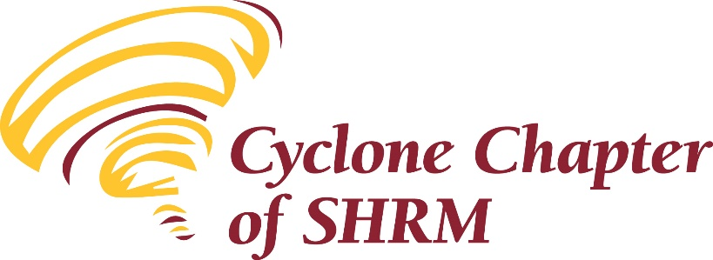 | 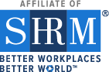

Meeting Minutes
July 9, 2020

President Frank called the meeting to order at 8:05 am. Introductions were done via the chat function on Zoom. There were 41 attendees participating in the meeting. Attendance was taken by reviewing the chat replies.

Brenda Dryer facilitated an icebreaker. Attendees were split into groups and asked to share “Their ideal vacation if money and time didn’t need to be considered.”

The following job opportunities were shared: Payroll position at Greene County Hospital in Jefferson and a Benefits Coordinator opportunity at Mary Greeley Medical Center.

Motion by Chelsey Aisenbrey, second by Tammy Stegman to approve the June financial reports with the following balances:
- Checking – 19,416.87
- Savings – 1,783.48
- CD #1 – 11,108.16
- CD #2 – 5,422.69
Vote taken via chat function on Zoom; motion approved.

Minutes from the June meeting were not available. These will be considered at the August meeting.

The following committee reports were presented:

Lauren Cook, Vice President / Membership, reported we have received applications for membership from a number of new people. An effort is being put forth by the Executive Committee to attract “At Large” national members to join our chapter.

College Relations chair, Tammy Stegman reported that the student chapter is filling out applications for national SHRM membership. This is an important step to get the chapter affiliated again. They will also become members of our chapter. Tammy extending her thanks to the members that volunteered to be interviewed by the student chapter.

Annemarie Miller, Diversity reminded the chapter about the D & I resources on the SHRM website.

Education Chair Cheryl Baker announced that this session will qualify for CEU.

The Executive Committee is analyzing options for a Foundation fundraiser.

In chapter New Business; the Iowa SHRM Conference will be held at the Coralville Marriott September 24-25th.

Heather announced SHRM Tune in Tuesday digital starts July 14th and will continue the 2nd Tuesday of each month via the SHRM website. The first session will feature a lively discussion between former Chief Talent Officer at Netflix Patty McCord and Johnny C Taylor Jr. SHRM President and CEO about the topic of her best-selling book “Powerful: Building a Culture of Freedom and Responsibility”

The business meeting was adjourned.

Heather introduced Christine Bestor Townsend. She is an attorney with Ogletree. She proactively assists employers in complying with state and federal employment laws, navigating complex leave and accommodation situations. For the last four months, a substantial part of her practice has been assisting employers with COVID related issues. Christine represents employers before federal and state courts and administrative agencies throughout the country (and most frequently in Iowa, Wisconsin, and Illinois), including in the areas of trade secret and noncompetition, wage and hour, employee benefits, and employment discrimination.

The session was entitled “Navigating the FMLA and the ADA” In this interactive presentation, we discussed employers’ obligations under the ADA and FMLA – two distinct laws which often overlap. We discussed various qualifying conditions, what FMLA situations should put individuals on notice, and various hypotheticals and real-world examples to help participants gain a greater understanding of these complex laws.

In closing Heather thanked everyone for their participation. A survey will be sent via survey monkey following this meeting to get feedback on this type of meeting and the topic in general.

Brenda S. Dryer
Acting Secretary

