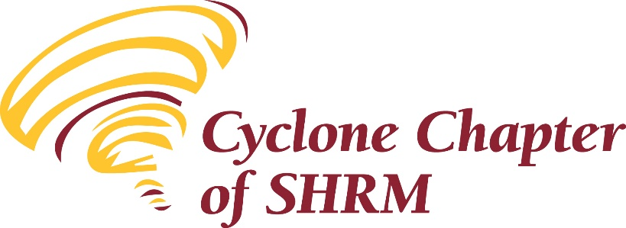 | 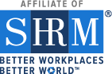

Meeting Agenda
June 11, 2020

Present:

Introductions:
- Attendees introduced themselves. Using Chat

Icebreakers 2020: In the wake of the social situations related to BLM movements, riots, protesting, amidst COVID-19 what is your employer doing? Are they addressing it, are they staying quiet on the topics?

Sharing of Accomplishments, Celebrations and Job Opportunities: None

Financials:
The May 2020, financial reports were attached to the meeting Announcements and Reminder. 5/31/20 Balances were:
- Checking – 20,416.87
- Savings – 1,783.41
- CD #1 – 11,092.30
- CD #2 – 5,418.03
Julie M move to approve
Cheryl 2nd
Motion Carried

Minutes:
The minutes of the May 2020 meeting were attached to the June meeting announcements.
Motion to approve the minutes; 2nd; use chat box to approve or thumbs up; any opposed?
Tammy S move to approve
Kevin S 2nd
Motioned carried

Committee Reports:
  - Vice President / Membership, Lauren Cook: Update name for attendance in chat
  - Treasurer, Kevin Stow – None
  - College Relations, Tammy Stegman- Reviewing national membership for student group,
  - Diversity, Annemarie Miller – Local opportunities for diversity; reach out to the team if you want to explore options for your workplace
  - Education, Cheryl Baker-This program is approved by SHRM for 1.5 CEU’s. This program has NOT been pre-approved for recertification through HRCI, however you may still submit the above program information as part of your recertification portfolio for review and approval by HRCI.If you need a Certificate of Attendance, please place your name in the chat box during the Zoom meeting and indicate you need a certificate and we will email those out to those who requested.
  - Foundation, Anne Peterson- New approaches coming
  - Technology, Lisa Atchison-Charleston - none

New Business:
- The Cyclone chapter has been awarded the 2019 Platinum Excel Award. Thank you to our past president Brenda Dryer for completing our application for consideration and thank you all for your continued support in our chapter initiatives which allow us to be awarded this great status.

We will continue to meet via Zoom in June, July and August. We hope that we will be able to be back together in September for our member appreciate event, but I will keep you updated as our meetings approach.
- Starting July, on the 2nd Tuesday of each month SHRM will be presenting a digital series of interactive episodes

Old Business:
- 5 scholarships for SHRM-CP or SHRM-SCP certification by Sept 1 (sent in April will resend after meeting)
  - Registered members
  - Attend 4 meetings in 2019 or 2020
  - Register by 10/16/2020
  - Test Dec 1 – Feb 15
  - Pass and provide proof for reimbursement

Business meeting adjourned.

Leslie Ginder, with a presentation titled Creating a Culture of Disability, Inclusion and Compliance
- Speaker Bio: Leslie Ginder, SHRM-CP, is an HR Specialist in disability accommodation and leave at Iowa State University. Leslie’s career has focused on disability and employment, including university career services and vocational rehabilitation. Leslie has presented on inclusion and accessibility for CUPA-HR and the Association of Talent Development, and taught an Honors course at Iowa State on Ableism in the Spring 2020 semester. She is completing her MS in Leadership Development at Drake University in August and has a BS in Human Services.
- Session Description: The CDC has found that one in four Americans have a disability. The US Census Bureau reports that “one-third of Americans are showing signs of clinical anxiety or depression” during the COVID-19 pandemic. Employee’s need to access workplace accommodations may be higher than ever before, yet the rate of employment for persons with a disability is 19.3%, according to the BLS. In this session, participants will learn strategies and smart practices to building and enhancing their workplace efforts in compliance and inclusion, specific to the population of employees with disabilities.
Closing
Thank you to Leslie for joining us today. Thank you to you all for your participation in this new meeting format. Survey sent via survey monkey following this meeting to get feedback on this type of meeting and the topic in general. Appreciate your participation in that survey.

